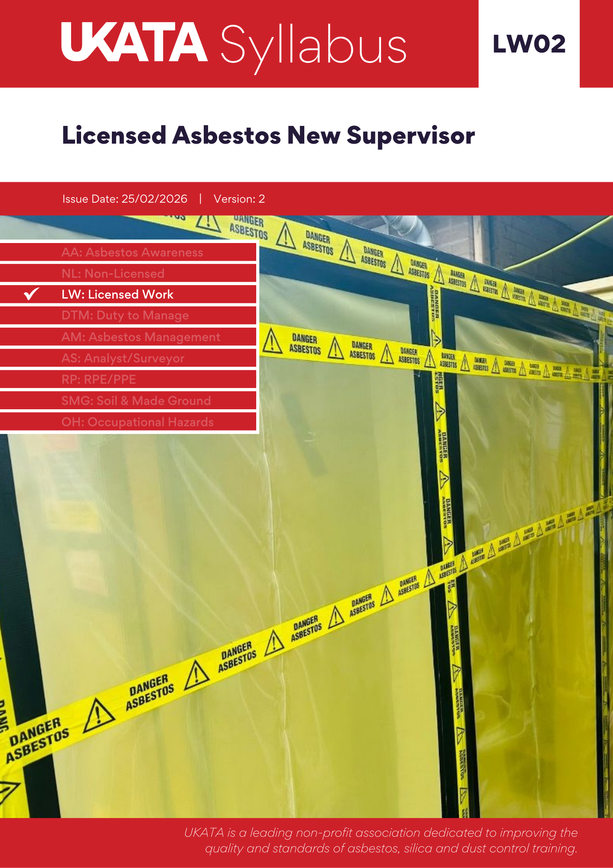

Recognition and Grants

 | This UKATA syllabus has been mapped against the CITB standard and is available for grant payments to levy registered employers.
  Training Type | Grant Tier | Grant Rate | Grant Code
  Initial | 2 | Up to 50% of training cost | GET2823
  Refresher | 2 | Up to 50% of training cost | GET2824
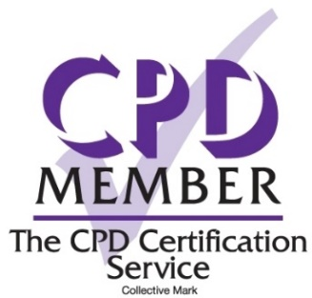 | UKATA is a Member of The CPD Certification Service providing recognised independent CPD accreditation compatible with global CPD principles.
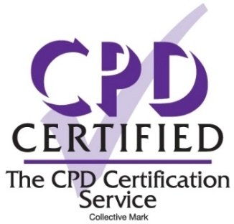 | This UKATA syllabus has been reviewed and independently certified as being suitable for CPD purposes by The CPD Certification Service.
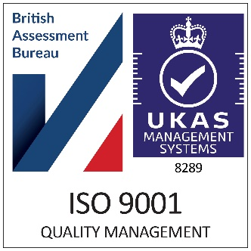 | UKATA holds ISO 9001 certification and continues to maintain the quality standard through annual auditing. ISO 9001 is a global standard for quality management systems (QMS), requiring organisations to demonstrate that their internal procedures meet rigorous guidelines, ensuring consistent delivery of quality products and services to customers and stakeholders.

Contents

Title | Page No
- Course Title | 4
- Introduction | 4
- Purpose/Scope | 4
- Occupational Relevance | 4
- Duration | 4
- Learner Pre-Requisites | 4
- Individual Learning Needs | 5
- Instruction/Supervision | 5
- Delivery | 5
- Assessment | 5 - 6
- Quality Assurance | 6
- Renewal/Refresher | 6
- Approval Date | 6
- Review Cycle | 6
- Additional Resources | 6
- Learning Outcomes | 7
- Required Course Content - Theory | 8 - 11
- Required Course Content - Practical | 12
- Asbestos Training Transition Modules Required | 13

1. Course Title
Licensed Asbestos New Supervisor
2. Introduction
This syllabus sets out the guidance issued by UKATA for the provision of licensed asbestos new supervisor training for employees whose supervision will guide the handling of asbestos-containing materials (ACMs) in a capacity that requires a license, as defined under the Control of Asbestos Regulations 2012. While this type of work has historically been guided by HSG247 – Asbestos: The Licensed Contractors' Guide, it is now also encompassed within UKATA LTG23: The Licensed Training Guide, which updates and replaces Chapter 4 of HSG247 to ensure the training is fit for purpose.
In recognition of career progression within the asbestos removal industry, this syllabus incorporates "Progressive" learning for individuals transitioning from Operative to Supervisor roles. It adapts course content to build on existing knowledge while introducing new supervisory skills as detailed in LTG23. This targeted approach ensures efficient training by focusing on new responsibilities instead of repeating familiar content. See section 19 for guidance.
This document provides the syllabus for the training along with guidance on the minimum content of all courses. Tutors can offer bespoke or tailored training for the remainder of any training session, but the core content must be adhered to.
3. Purpose/Scope
The purpose of this training is to equip learners with both theoretical knowledge and practical skills necessary for the effective supervision of safely working with licensed asbestos-containing materials (ACMs). This training is designed to advance understanding of the hazards and risks posed by ACMs, elevate proficiency in supervisory skills over advanced removal and containment techniques, and ensure compliance with stringent health and safety legislation applicable to licensed asbestos removal.
4. Occupational Relevance
This training is exclusively intended for new supervisors who are employed by organisations holding an HSE asbestos removal license. It is designed for those responsible for overseeing the removal of high-risk asbestos-containing materials (ACMs) under the stringent regulations outlined in CAR 2012, Reg 3(2). The course targets individuals who will supervise the handling and removal of asbestos in settings that demand a licensed contractor due to the friability and hazardous nature of the materials involved, such as thermal insulation, asbestos insulating board, and sprayed coatings.
5. Duration
Minimum of 12 learning hours.
(This includes a minimum of 6 learning hours of practical training and the time allocated for the final exam)
6. Learner Pre-requisite
Learners must have a minimum of 12 months experience as an asbestos removal operative and must have successfully completed a UKATA Licensed Asbestos New Operative or Operative Refresher course within the last 12 months. Proof of this training must be verified by the training provider and should be dated no earlier than 12 months prior to the start of the course.
Learners without a previous UKATA certificate may still attend a UKATA licensed training course, provided the training provider or tutor carries out appropriate checks against the delegate’s CV or experience to determine course suitability.
7. Individual Learning Needs
The tutor must assess each learner’s individual needs before the course begins and adapt the training accordingly.
8. Instruction/Supervision
As a minimum, tutors must meet the following criteria:
- Tutors must have a minimum of at least three years’ experience (within the past five years) in the asbestos industry. This will be taken to include, surveying, analytical, removal, consultancy, training, management etc. and must be able to demonstrate a comprehensive practical working knowledge, within the asbestos industry, including its legislative requirements;
- A good understanding of HSE Guidance: HSG247;
- Be able to demonstrate experience of delivering Licensable Training;
- Hold a suitable asbestos qualification recognised by the asbestos industry, which may include: asbestos surveying, asbestos management or asbestos removal, or other such qualifications that UKATA deems to be acceptable;
- Hold a recognised trainer qualification, i.e., Level 3 Award in Education and Training, or you must achieve this qualification within 12 months of registration with UKATA;
- A successful UKATA Audit, or an internal Audit undertaken by the Member company they are working for at the highest category of training the Tutor will deliver on behalf of the Member;
- After meeting the above criteria, the Tutor is required to pass the UKATA Licensable Tutor Knowledge Test.
9. Delivery
Training must be delivered in a suitable environment and in accordance with the UKATA Training Centre & Equipment Minimum Standards. All equipment must be of a suitable quality and quantity for learners to achieve learning outcomes and must comply with relevant legislation.
The class size and tutor to learner ratio must allow training to be delivered in a safe manner and enable learners to achieve learning outcomes. The approved training delivery methods for this training along with the maximum tutor to learner ratios are:
Classroom: 1:12 (theory) 1:6 (practical)
Virtual Classroom: 1:6 (theory) (refresher training only)
10. Assessment
Attainment of the learning outcomes will be assessed by a multiple-choice exam consisting of at least 45 questions taken from the UKATA question bank and sat under exam conditions. At the discretion of the tutor, learners shall be permitted to refer to any notes they make during the training session, or the training manual/notes provided by the tutor.
Learners will be required to achieve a score of at least 36 out of 45 (80%) in the exam. Failure to achieve this will result in the learner requiring to re-sit the exam under exam conditions. If a learner fails the second attempt, they will be required to re-sit the course in its entirety.
The exam should have a completion time of approximately 60 minutes, though this is intended as a guideline. Tutors should accommodate the diverse needs of learners, which may include reading the questions aloud when necessary. However, no assistance may be provided in answering the questions.
11. Quality Assurance
Quality assurance against this syllabus requires verification and approval of the presentation materials, exam papers, course handouts and tutor narrative. Independent audits are carried out to demonstrate conformity with the training standards set by UKATA and each tutor maintains a CPD record that aligns with the UKATA Tutor Competency Framework.
UKATA prides itself on numerous accreditations and certifications that reflect our commitment to the highest standards of service and quality. A detailed list of these can be accessed at: UKATA Accreditations.
12. Renewal/Refresher
Certification for this training course will be valid for one year.
Annual refresher training is required for licensed asbestos supervisors, and more frequent refreshers may be necessary if there are changes in work methods, equipment, or significant alterations in the type of work. Refresher courses are also recommended if any gaps in competency are identified.
The duration of refresher training is determined by a training needs analysis (TNA) conducted by the training provider and should be a minimum of 4 learning hours.
Learners must provide evidence of their previous UKATA Licensed Asbestos Supervisor (or refresher) training, completed within the last 12 months. Where a learner is unable to provide evidence of recent certification, the training provider may, in exceptional circumstances, determine suitability for refresher training through a documented TNA. This should be supported by evidence of the learner’s knowledge, skills, and experience (e.g. CV, work history, or employer confirmation).

Where sufficient prior competence cannot be evidenced, the learner must complete the full initial training course.

Following the certification expiration date, a grace period of one month is permitted for refresher training
to be delivered. The employer should, in this case, carry out a TNA and discuss the training requirements
with the training provider.

13. Approved Date
01/02/2025
14. Review Cycle
Either on request or within 3 years from approval date.
15. Additional Resources
View | Managing and working with asbestos - Control of Asbestos Regulations 2012(CAR 2012) - Approved Code of Practice and guidance.
View | HSG247 Asbestos: The licensed contractors’ guide.
View | Licensable work with asbestos – HSE.
View | LTG23 Asbestos: The licensed training guide.

16. Learning Outcomes
- Recognise asbestos types and associated risks, including methods for confirmation through analysis.
- Understand the health hazards of asbestos, emphasising medical surveillance requirements.
- Grasp comprehensive duties under the licensing framework and CAR 2012, focusing on exposure control and compliance with waste management regulations.
- Oversee setup, maintenance, and dismantling of removal sites, including management of enclosures and hygiene units.
- Ensure proper use and maintenance of essential equipment for asbestos removal, emphasising safety compliance.
- Develop and manage risk assessments and plans of work, adapting to changes and ensuring compliance with legal notifications.
- Supervise controlled stripping techniques to ensure effective fibre suppression and exposure control.
- Manage the use, maintenance, and decontamination of PPE and RPE, ensuring correct application and compliance with safety standards.
- Direct emergency procedures and manage decontamination processes to ensure readiness for any incidents.
- Supervise cleaning and air testing protocols to guarantee area safety post-asbestos removal.
- Ensure all personnel receive necessary training and information, maintaining records of activities and compliance with health and safety standards.
- Uphold the supervisor's responsibilities in maintaining work standards, legal adherence, and safety of all personnel involved in asbestos operations.

17. Required Course Content – Theory
MODULE 1 | Types, uses and risks of ACMs
MODULE 1 | Types of asbestos fibres – characteristics, uses, identification methods (introduction), nature and levels of risk for different groups of ACMs; history of import, manufacture, and installation of different ACMs; types of products that may contain asbestos; likely locations; previous treatment methods covering old asbestos applications; ACMs’ friability/conditions when they will release fibres; recognition and need for control; emergency and remedial work, surveys (overview). Plus, know how the presence of asbestos can be confirmed (bulk sampling and analysis).

MODULE 2 | Health hazards of asbestos
MODULE 2 | How fibres cause disease; types of asbestos-related diseases and how related to exposure; medicals under CAR; need for dust/fibre suppression to control exposure; need for correct use/ maintenance of RPE; health effects of smoking and risks of taking home asbestos-contaminated equipment/clothing etc.

MODULE 3 | Legislation
MODULE 3 | Duties of the individual; key duties of the employer; overview of the licensing framework; control of exposure- as low as reasonably practicable; overview of CAR; requirements of the ACOP and associated guidance; overview of waste regulations and Environmental Protection Act and overview of REACH 2009. With emphasis on responsibilities of supervisor.

MODULE 4 | Site set up, maintenance and dismantling
MODULE 4 | Set up: Need for pre-clean; vacuum cleaners; site layout, including siting of hygiene unit as close to enclosure as possible; optimal positioning of air/baglocks and NPUs; explanation of how NPUs work and the significance of the voltmeter and pressure gauges and what changes in the gauge readings mean; when pre-filters should be changed; connection and testing of hygiene unit; construction of enclosures, air/baglocks including possible weather protection; positioning of clear viewing panels; positioning and wording for warning notices and barriers; how to delineate work areas and transit routes; smoke testing and need for witnessing.  Maintenance: Daily inspections of enclosure (start, middle and end of shift) and immediate rectification of defects; strategy for NPUs to be kept running after stripping finishes for the day.  Dismantling: Once clearance achieved, spray enclosure with sealant, bag and seal vacuum cleaners, bag other equipment, dismantle polythene and dispose of as asbestos waste; final inspection of area once enclosure and all associated equipment have been removed. Where construction of enclosures on scaffold or where scaffold is used inside an enclosure, the boards, tubes, clips, tube ends will need protecting.  Recognise which ACMs are not being removed as agreed with client, check certificates for hygiene unit NPU, gas test, clearance in shower and dirty end from previous job, NPUs and vacuum cleaners; how to check for negative pressure in the enclosure; ensure that viewing panels (or other viewing means eg CCTV or webcams) are provided and covering all enclosure work areas. Strategy for air management. Undertake all necessary gas and electric pre use checks.

MODULE 5 | Plant and equipment (using demonstration of equipment)
MODULE 5 | Equipment components: equipment use and maintenance including: NPUs and monitors, class-H vacuums and injection equipment; Siting and daily maintenance of the hygiene unit; recordkeeping (RPE covered separately).

MODULE 6 | Non-asbestos hazards
MODULE 6 | Site safety procedures; permit-to-work systems; entry and exit in case of fire; location of possible site hazards; emergency procedures in case of fire, electric shock, burns, hazardous substances, solvents etc; care of injured casualty; manual handling, noise, vibration and falling object protection, slips, trips and falls, eg working from scaffolding. Plus, electrical checks for DCU.

MODULE 7 | RAs and POWs
MODULE 7 | Introduction to RAs (know what they are for) – understanding the main points, right to see significant findings; requirements to follow RAs and risks/penalties if not followed; the meaning of the control limits and action levels. Plus, carrying out RAs and developing a POW (instruction and exercise); changes and amendments to RA/POW; seeking advice and informing of changes; notification to HSE when change is significant and what is a significant change.

MODULE 8 | Controlled stripping techniques
MODULE 8 | The principles of fibre suppression and control of exposure; equipment – use of, maintenance and cleaning; wet injection and spraying techniques; wrap-and cut; direct vacuuming; LEV (shadow vacuuming); vacuum transfer; air management; preparation time and testing of controls before removal; wetting agent selection, preparation and use; COSHH requirements; anticipated and desired fibre levels and comparison with RPE maximum exposure levels; personal assessment monitoring (principles); access to personal assessment information. Plus, equipment inspections and records, fault-finding, and solutions. Monitoring for effectiveness of fibre control techniques and recording information.

MODULE 9 | Respiratory protective equipment
MODULE 9 | The circumstances when RPE must be worn which may include inspection of work area, building and dismantling enclosures, working in enclosure, taking bags to skip; how to inspect, test and wear respirator; need for quantitative face-fit test, a good face seal and the need to be clean shaven; correct storage, battery charging and keeping clean; strategy for changing pre-filters and main filters.

MODULE 10 | Personal protective equipment and clothing
MODULE 10 | The use of the appropriate PPE including overalls, headgear, footwear, and gloves; employer requirements to provide appropriate PPE and employees’ obligations to use it; care, wearing, cleaning, decontamination and/or disposal of PPE; not taking contaminated PPE out of designated areas; transit overalls; when and where PPE should be worn; ensure correct use and maintenance of PPE. Plus, PPE use during transit procedures; contaminated clothing and waste; keeping of relevant records.

MODULE 11 | Waste management and disposal
MODULE 11 | Bagging, sealing, and cleaning; transportation through baglock and airlock; storage of asbestos waste; correct loading of skip/van. Plus, outline of Waste Regulations; use of consignment notes; registration of carriers; role and powers of environment agencies; transportation of dangerous goods; bagging, sealing, and cleaning.

MODULE 12 | Cleaning and clearance air testing
MODULE 12 | Cleaning and clearance requirements, including the need for the four-stage clearance process and associated certificate of reoccupation; visual cleanliness and air testing requirements; methods of cleaning for enclosures, hygiene facilities and equipment; re-cleaning in event of air test failure; cleaning after enclosure dismantling; cleaning in the event of an emergency or enclosure/equipment damage. Plus, the requirements of analysts before clearance inspection and sampling (including completion of supervisor handover certificate).

MODULE 13 | Transit procedures and decontamination
MODULE 13 | Personal decontamination procedures for directly connected and remote (transit) DCUs and airlocks including: PPE changing and disposal, showering, colour coding of coveralls, RPE decontamination, cleaning, charging and storage; use of towels; changing and disposal of pre and main RPE filters; decontamination procedures where no enclosure or DCU is required (open sites); common problems with decontamination; cleaning of airlocks and DCUs; emergency decontamination in case of evacuation or accident; what should be in the DCU, i.e. mirror, soap/ shower gel. Plus, common problems, and fault-finding with decontamination; air monitoring results in DCUs; inspection and record-keeping; the importance of ensuring that procedures are followed; making time available to allow adequate showering; DCU checks.

MODULE 14 | Fault-finding
MODULE 14 | Work practices – how to spot problems with wetting of ACMs, RPE, airlocks, enclosures, and hygiene unit; method statements; RAs; signs; record-keeping and fault reporting procedures.

MODULE 15 | Site inspection and record-keeping
MODULE 15 | Purpose of site inspections, site auditing and record keeping; role of inspector/auditor; responsibilities of operatives; reporting faults and other problems. Plus, criteria, for site inspections; actions in event of faults; record-keeping; scope and nature of records, use of typical record and reporting systems (including electronic devices eg tablets).

MODULE 16 | Emergency procedures
MODULE 16 | What to do in the event of major and minor injuries or illnesses occurring inside ‘live’ enclosures; what to do in the event of fire, or some other hazardous release such as toxic gas or radioactive dust occurring inside or outside enclosure; what to do if a leak of asbestos is found outside the enclosure; what to do if power on power-assisted respirator fails while inside ‘live’ enclosure; what to do if the NPUs stop working; what to do if there is complete loss of electrical power; what to do if loss of water supply to hygiene unit. Confirming the responsibility of the supervisor to ensure that suitable emergency procedures are in place to cope with the failure of any control measures or the injury or ill health of a worker inside contaminated areas.

MODULE 17 | Management systems and monitoring
MODULE 17 | Maintenance and monitoring of control measures; controlling exposure to asbestos; ensuring that equipment functions correctly; pre-start setting-up; barriers and signs; construction and testing of enclosures and airlocks; site monitoring; use/testing of negative pressure equipment and ventilation and air management systems; correct maintenance of all site equipment - following manufacturers’ operating instructions, including the correct maintenance and monitoring of the following control measures: enclosures, external services, NPUs, wet strip units, mobile generators, water supply, heating appliances, PPE, RPE, any dust suppression equipment, tools and DCUs. Plus, site supervision and record-keeping of work in progress; method statements; POWs; monitoring and auditing work in progress.

MODULE 18 | Roles and responsibilities
MODULE 18 | To ensure everyone complies with regulations, ACOPs, guidance and follows the RA and POW. If the work method has to change - work is stopped and reassessed. The RA and POW are amended, and personnel informed of the changes in writing; to ensure all personnel are instructed, face-fitted and have received a medical; all equipment is inspected and tested; all daily inspections are carried out; all documentation is available and up to date; the importance of being on site for key stages of the work and their crucial role in directing the work and monitoring standards of work.

MODULE 19 | Information, instruction and training
MODULE 19 | How to implement and monitor on-job training (consolidation); how to assess the competence of employees; the types of training available and how to choose the right course; TNA in practice; recognising the need for additional training when new equipment or work methods are introduced.

- Required Course Content - Practical
MODULE 20 | Decontamination and transit procedures
MODULE 20 | N/A

MODULE 21 | Use and maintenance of RPE
MODULE 21 | Fault finding RPE with emphasis on the importance of ensuring all certification and documentation of all RPE.

MODULE 22 | Construction of enclosures and airlocks
MODULE 22 | Fault finding and enclosure inspections

MODULE 23 | Use of controlled stripping techniques
MODULE 23 | Specific fault finding within all aspects of injection , vacuum, set up and cleaning.

- Asbestos Training Transition Modules Required
To support progressive learning for operatives transitioning to a supervisor role, specific transition modules are available. These modules allow experienced operatives to skip foundational content and focus on acquiring supervisory skills essential for their new responsibilities. The transition emphasises modules critical to supervisory duties, allowing for a more targeted and efficient learning experience. Key aspects include legal framework enhancements, practical assessments in site setup, and advanced compliance monitoring, ensuring that learners are well-prepared for supervisory challenges.
Module | Requirements | Additional practical modules and assessments
1. Types, uses and risks of ACMs | Not Required
2. Health hazards of asbestos | Not Required
3. Legislation | As per module, with additional information to legal framework and supervisor responsibilities
4. Site set up, maintenance and dismantling | As per module | NPU calculations. Practical enclosure assessment, form completion
5. Plant and equipment (using demonstration of equipment) | As per module
6. Non-asbestos hazards | As per module
7. RAs and POWs | As per module | Undertake practical RA and POW for an area with the training centre, discuss and critique
8. Controlled stripping techniques | As per module – Thorough understanding of compliance monitoring. | Discussion based on a practical scenario where compliance monitoring will be required and calculated
9. Respiratory protective equipment | As per module | Practical RPE fault finding
10. Personal protective equipment and clothing | As per module
11. Waste management and disposal | As per module
12. Cleaning and clearance air testing | As per module – Supervisor Handover Form | Practically undertake a supervisor visual
13. Transit procedures and decontamination | As per module
14. Fault-finding | As per module | Practical Fault-finding exercise of a work areas, fault finding POW
15. Site inspections and record-keeping | As per module
16. Emergency procedures | As per module
17. Management systems and monitoring | As per module
18. Roles and responsibilities | As per module
19. Information, instruction, and training | As per module and understanding of TNA and competency assessments
20. Decontamination and transit procedures | Not Required
21. Use and maintenance of RPE | Not Required
22. Construction of enclosures and airlocks | Not Required
23. Use of controlled stripping techniques | Not Required

